The reaction is an example of: 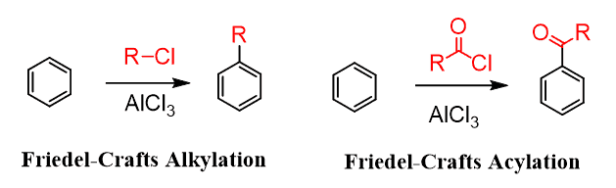
A. Friedel Craft Alkylation
B. Friedel Craft Acylation
C. Both of these
D. None of these
ANSWER: B
Which of the following substitution reactions take place in benzene?
A. Free radical
B. Electrophilic substitution reaction
C. Nucleophilic substitution reaction
D. All of these
ANSWER: B
It activates the benzene ring.
A. Electron withdrawing deactivating group
B. Electron donating activating groups.
C. Electron donating deactivating group
D. Electron withdrawing activating group
ANSWER: C
Which of the following reaction take place in the presence of catalyst?
A. Halogenation
B. Alkylation
C. Sulphonation
D. All of these
ANSWER: D
Which of the following substitution reaction take place in Benzene?
A. Free radical
B. $E^{+}$substitution
C. ${Nu}^{-}$substitution
D. All of these
ANSWER: B
Benzene ring structure was given by
A. Kekule
B. Faraday
C. Robinson
D. Dewar
ANSWER: C
Which of the following is correct statement?
A. Benzene behave as unsaturated compound in electrophilic substitution reaction
B. Benzene behave as saturated compound in addition reaction
C. Benzene behave as unsaturated compound in addition reaction
D. Benzene behave as saturated compound in addition reaction
ANSWER: C
Which of the following is isolated polycyclic?
A. Biphenyl
B. Naphthalene
C. Anthracene
D. All of these
ANSWER: A

It is also known as toluene.
A. 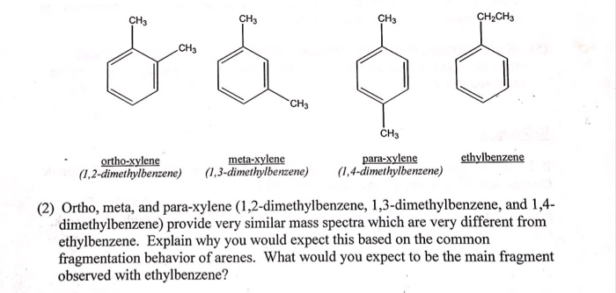
B. 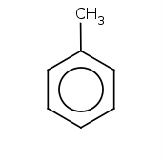
C. 
D. None of these
ANSWER: A

Which of the following molecule shows benzoic acid?
A. 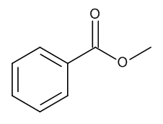
B. 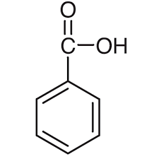
C. 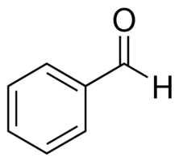
D. 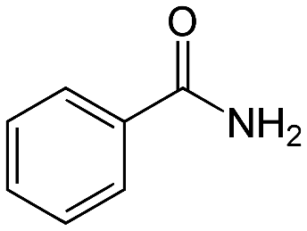
ANSWER: B
Alkyl benzene will form when benzene undergo_____.
A. Nitration
B. Sulphonation
C. Alkylation
D. Halogenation
ANSWER: C
In which of the following reaction, benzene ring will not be retained?
A. Addition
B. Halogenation
C. Hydrogenation
D. All of these
ANSWER: D
Reaction of benzene with halogen in the presence of sunlight is an example of
A. Electrophilic substitution reaction
B. Nucleophilic substitution reaction
C. Addition reaction
D. None of these
ANSWER: C
In which of the following reaction, benzene behave as saturated compound?
A. Halogenation in the presence of UV
B. Halogenation in the presence of catalyst
C. Oxidation with $O_{2}$in presence of $V_{2}O_{5}$
D. Reaction with $O_{3}$
ANSWER: B
Kekule structures have ___ resonance structures.
A. 2
B. 3
C. 4
D. None of these
ANSWER: A

